# Q1:

#include <iostream> #include<fstream> using namespace std; int main(){

fstream FileName; FileName.open("FileName", ios::out); if(!FileName){

cout<<"Error While Creating the file";

}

else {

}

cout<<"File created sucessfully"; FileName.close();

return 0;

}

**OutPut:**

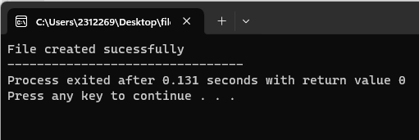

#include <iostream> #include<fstream> using namespace std; int main(){

fstream new_File; new_File.open("FileName.txt", ios::out); if(!new_File){

cout<<"file creation failed";

}

else {

}

cout<<" New File created";

new_File<<"ali is a good boy and he lives in California."; new_File.close();

return 0;

}

**Output:**

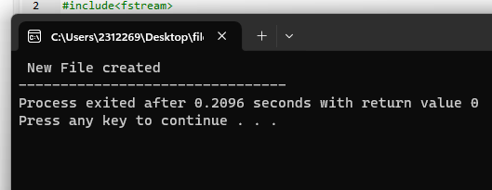

#include <iostream> #include<fstream> using namespace std; int main(){

fstream FileName; FileName.open("FileName.txt", ios::out); if(!FileName){

cout<<"file dosn't exist.";

}

else {

}

char x; while(1){

FileName>>x; if(FileName.eof()) break;

cout<<x;

}

FileName.close(); return 0;

}

**OutPut:**

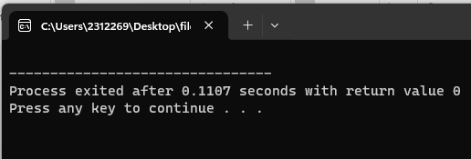

#include <iostream> #include<fstream> using namespace std; int main(){

fstream new_File; new_File.open("FileName.txt", ios::out); new_File.close();

return 0;

}

**Output:**

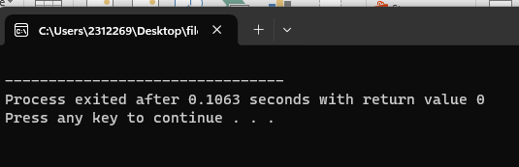

# Q4:

#include <iostream> #include<fstream> using namespace std; int main(){

ofstream fout;

string line; fout.open("sample.txt"); while(fout) {

getline(cin, line);

if(line == "-1") break;

fout << line <<endl;

}

fout.close(); ifstream fin;

fin.open("sample.txt"); while (getline(fin, line)) {

cout<< line <<endl;

}

fin.close(); return 0;

}

**Output:**

